Formal Project Proposal Template
Due 7 March 2024
Name: | Farinaz Tanhaei
Programme: | MSC DATA SCIENCE
Student ID: | 23044867
Project Title: | Predictive Modelling of Business Turnover based on Geographical and Business factors in the UK
Problem you are seeking to address: | The wide-ranging economic impact of business turnover in the UK emphasizes its significance. Turnover is the rate at which a business sells everything it owns, gets payments in relation to sales, or replaces its assets during a given time frame. Generally speaking, turnover examines how quickly and well a business operates [1]. Furthermore, the primary factor influencing a business's return on equity is asset turnover. Because businesses spend a lot of money in their assets, making good use of them is essential to overall profitability. An in-depth examination of asset turnover enables the analyst to assess how well a company manages its investments [2].  In this effort, we want to forecast turnover of a business based on its various features to the promotion of economic development and stability. In this regard, we will employ the “Annual business population estimates for the UK and regions in 2023” dataset [3]. This dataset contains 2080 instances with 6 features. This enables us to train trustworthy machine-learning models [3].
Aim and scope: | We believe a systematic analysis of this data (contain Data Preparation, Exploratory Data Analysis (knowledge learnt from the courses)) might give us a decent perception of the data to choose appropriate machine learning algorithm to predict Business Turnover.  In addition, we aim to use XAI on the models to provide some trustworthy machine learning models.
Project objectives: | - Analysing the data and providing a comprehensive report.  - Applying different machine learning models.  - Performing XAI on the ML models
Expected project outcomes: | - Develop a comprehensive report that provides an in-depth analysis of the Annual business population estimates for the UK and regions in 2023 dataset.  - Include statistical analysis of the data but also insights into the patterns and correlations among different features.  - Detailed understanding of the data is expected to guide the subsequent stages of model development and validation.  - Apply various machine learning models, including ensemble learning techniques, to predict Business Turnover.  - Achieve high accuracy in predicting Business Turnover.  - Apply Explainable AI (XAI) techniques to these models.  - Provide valuable insights into the factors that contribute most significantly to the prediction.  - We hope that our project will help businesses stay competitive and potentially lead to an increase in their market share.
Brief review of relevant literature: | Machine learning (ML) transforms economic analysis through advanced algorithms and vast datasets, excelling in predicting complex phenomena and overcoming traditional method limitations [4]. Some economic researchers have utilized ML to study the UK economy and make business predictions, with numerous models applied to datasets related to UK economic and business statistics [5, 6, 7].  there are also articles exploring the prediction of business performance using machine learning [8, 9], with a focus on financial ratios. These models can be updated and enhanced by applying more machine learning techniques [10].
[optional] References: | - Kenton, W. (2024) 'Turnover', Investopedia. Available at: https://www.investopedia.com/terms/t/turnover.asp (Accessed: 1 March 2024).  - Sneidere, R. and Kavale, L., 2013, September. The analysis of theoretical approaches for calculating turnover ratios. In DIEM: Dubrovnik International Economic Meeting (Vol. 1, No. 1, pp. 0-0). Sveučilište u Dubrovniku.  - Business population estimates 2023 (2023). https://www.gov.uk/government/statistics/business-population-estimates-2023 (Accessed: March 1, 2024).  - Storm, H., Baylis, K., & Heckelei, T. (2020) 'Machine learning in agricultural and applied economics', European Review of Agricultural Economics, 47(3), 849–892, https://doi.org/10.1093/erae/jbz033, Published: 21 August 2019.  - Suss, J., & Treitel, H. (2019) 'Predicting bank distress in the UK with machine learning', Staff Working Paper No. 831, Bank of England, October 2019.  - Sermpinis, G., Tsoukas, S., & Zhang, Y. (2022) 'Modelling failure rates with machine-learning models: Evidence from a panel of UK firms', European Financial Management, First published: 05 May 2022.  - Chakraborty, C., & Joseph, A. (2017) 'Machine learning at central banks', Staff Working Paper No. 674, Bank of England, September 2017.  - Song, Y., Cao, Q., & Zhang, C. (2018) 'Towards a new approach to predict business performance using machine learning', Cognitive Systems Research, Available online: 4 October 2018.  - Bonello, J., Brédart, X., & Vella, V. (2018) 'Machine learning models for predicting financial distress', Marmara İktisat Dergisi • Journal of Research in Economics, Cilt: 2, Issue: 2, October, ss/pp. 174-185. ISSN: 2528-8547. DOI: 10.24954/JORE.2018.22.  - Mahoto, N.A., Iftikhar, R., Shaikh, A., Asiri, Y., Alghamdi, A. and Rajab, K., 2021. An Intelligent Business Model for Product Price Prediction Using Machine Learning Approach. Intelligent Automation & Soft Computing, 30(1).
Testing and Evaluation: | - Analysing the data, linear correlation and non-linear correlations.  - Divide the dataset into two parts: training (k-fold cross validation), and testing.  - Apply different ML models.  - Apply XAI on the best models.
Ethical considerations: | The project will prioritize ethical considerations by focusing on maintaining data privacy, employing transparent data handling practices, and ensuring unbiased reporting.
Project plan: | 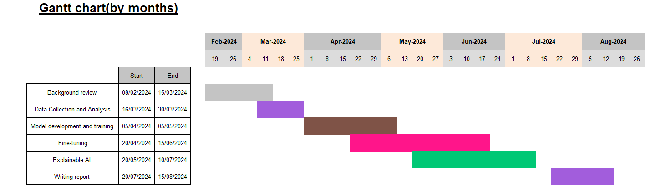
Signature: | Farinaz Tanhaei

Excluding your project title and references, your proposal should be a maximum of 1000 words in length. If using this template, then it would be at most 3 pages excluding references.

